Valpak’s Battery Box Service FAQs

Do I have to pay for Valpak’s Battery Box Service?
No, Valpak offers a free battery box service for any companies which are required to offer takeback of portable, household batteries. If any non-portable or non-household batteries, or more than 3% of lithium batteries, are placed in the box, you may be charged for the collection of these.

How long will it take for my box to be delivered?
We advise a delivery time of 4-6 weeks, due to the high demand of the service. If you have not received your delivery after 6 weeks, please send an email to info@valpak.co.uk, or call 03450 682572, and we will investigate.

How long will it take for my batteries to be collected?
Our batteries partners will generally complete the collection within 10 working days of us placing the order with them, which we do weekly. If your batteries have not been collected after 10 working days, please send an email to info@valpak.co.uk, or call 03450682572, and we will investigate.

How can I recycle non-household/non-portable batteries?
Car batteries, industrial batteries, batteries with connecting wires, and lead acid batteries, cannot be accepted through this scheme. If you need to recycle these or any other non-household or non-portable batteries, please take pictures of the batteries and email these to info@valpak.co.uk. We will discuss with you the options for recycling.

Can I put lithium batteries in Valpak’s Battery Box?
Lithium batteries are highly volatile with an explosive nature so large volumes should not be placed in the box. Our batteries partners will collect some waste lithium batteries, as long as they make up no more than 3% by weight of the total waste batteries being collected. If you have a large volume of lithium batteries to recycle, please send an email to info@valpak.co.uk, or call 03450682572, and we will discuss with you the options for recycling.

Can I arrange a collection for household/portable batteries which are not stored in a Valpak Battery Box?
Our batteries collection partners request that batteries should always be stored for collection in a Valpak box. To order a new battery box please send an email to info@valpak.co.uk, or call 03450682572.

What if the batteries will not fit through the battery box opening?
Larger household batteries may not fit through the opening, so consumers should be encouraged to hand them to store staff. These can either be stored safely nearby by prior to a collection, or the container can be opened up to place the batteries inside.

Can I order a battery tube Instead of a battery box?
We no longer offer new battery tubes to customers. However, if you have an existing tube, we can still collect these batteries.

Can I recycle vapes in Valpak’s Battery Box?
No, vapes cannot be placed in the battery boxes. We have a separate service for vape recycling, please email vapes@valpak.co.uk for more information.

Do I need to order a new battery box for each collection?
No, you do not need to order a new box for each collection, unless your current box is damaged. The driver will empty the batteries out and leave the box with you. The driver will not be able to provide you with a new box, so if you do need one, please send an email to info@valpak.co.uk, or call 03450 682572.

How big is the Valpak Battery Box?
The battery recycling boxes measure 265mm x 220mm x 240mm, and have a capacity of 15kg. Please see the reference picture below:
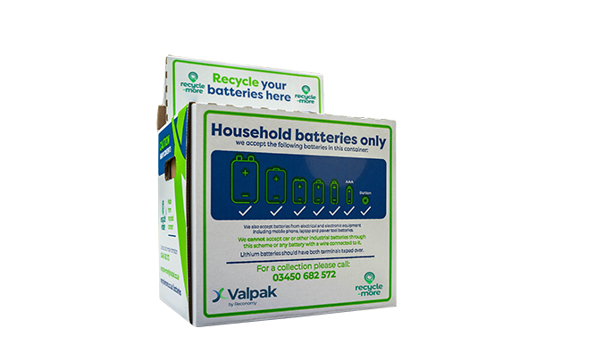

Will I receive a Waste Transfer Note for the batteries collection?
Yes, upon collection you can request a Waste Transfer Note from the driver for your records.

Will I need to provide my contact/address information for every order?
Yes, you will need to provide your contact details, address, and any supplementary information every time you order a new delivery or arrange a collection. This is to ensure all contact information is up to date and correct.

Can I arrange regular battery box collections?
No, due to the high demand of the service we cannot offer bookings for regular collections. You must get in contact with Valpak to arrange a new collection every time your box nears full.

Can Valpak provide a risk assessment for the battery box?
No, you must complete your own risk assessments and fire safety procedures. Valpak do not provide these, as risks can vary between sites.

Can I arrange for my batteries to be collected on a weekend?
No, our batteries partners are only able to organise collections on weekdays.

Can I keep a backlog of batteries to be picked up in one collection?
Storing large amounts of used batteries, especially when they are not contained in a Valpak Battery Box, is a fire risk. For health and safety reasons, we recommend that collections are arranged when each box is nearing full, and that you do not keep a backlog.

